Final Project

IT – 2206

Zhayleubay Alibek(221655)

Image Classification Report

Introduction

Problem

Image classification is a fundamental task in computer vision, where the goal is to categorize images into predefined classes. This report focuses on building a convolutional neural network (CNN) for classifying flower images into different categories.

Link : https://medium.com/ai-techsystems/flower-classification-using-cnn-801e8ba1776

Link : https://www.kaggle.com/code/rajmehra03/flower-recognition-cnn-keras

Current Work

The current work utilizes TensorFlow and Gradio to create an interactive interface for image classification. The model is trained on the Flower Photos dataset, and its performance is evaluated.

Data and Methods

Data Analysis

Dataset link: <https://storage.googleapis.com/download.tensorflow.org/example_images/flower_photos.tgz>

Total num of files: 6606

Num of classes: 5

The Flower Photos dataset is obtained from a publicly available source, and it consists of images of flowers belonging to various categories. Initial analysis includes exploring the dataset, visualizing sample images, and understanding class distribution.

Model Description

The deep learning model employed for image classification is a sequential CNN. The architecture includes convolutional layers with max-pooling, followed by fully connected layers. The model is compiled using the Adam optimizer and sparse categorical crossentropy loss.

Results

Training and Validation

The model is trained for 10 epochs on the training dataset, with validation conducted on a separate subset. Training and validation accuracy, as well as loss, are tracked over epochs.

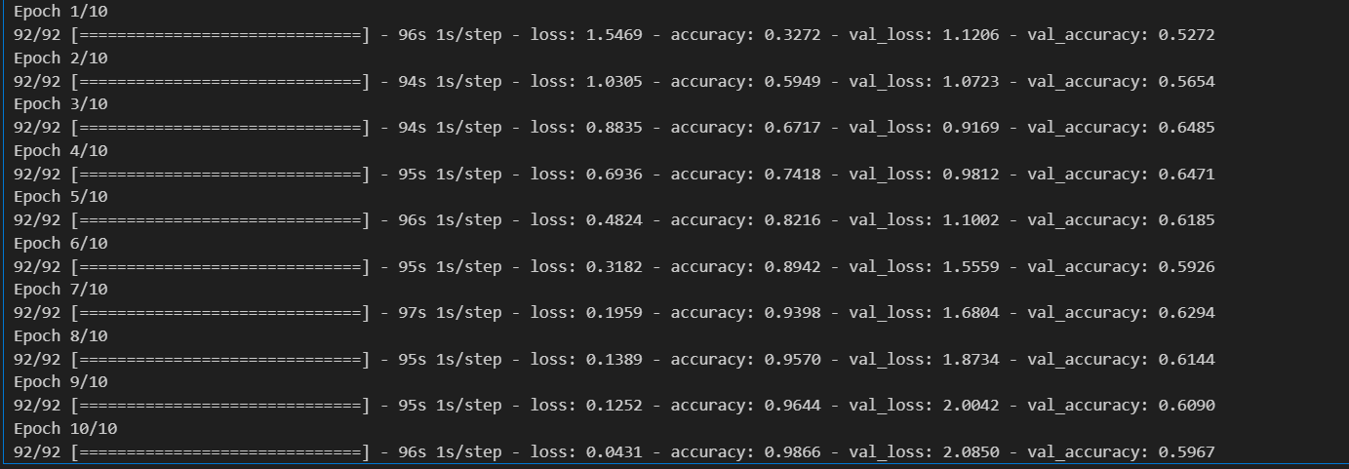

Visualizations

Visualizations include sample images from the training dataset, a confusion matrix, and learning curves to provide insights into the model's performance.

Discussion

Critical Review

An analysis of the results highlights the model's accuracy and areas for improvement. The impact of hyperparameters, potential overfitting, and the generalization ability of the model are discussed.

Next Steps

Possible next steps involve fine-tuning the model, exploring different architectures, or incorporating transfer learning to enhance performance. Additionally, expanding the dataset or applying data augmentation techniques could further improve the model's robustness.

Conclusion

In conclusion, this report presents an image classification solution using a CNN model trained on the Flower Photos dataset. The findings offer insights into the model's performance and lay the groundwork for further improvements.

References

TensorFlow Documentation: https://www.tensorflow.org/api_docs

Gradio Documentation: <https://www.gradio.app/docs/interface> , https://www.gradio.app/docs/image

Flower Photos Dataset: https://storage.googleapis.com/download.tensorflow.org/example_images/flower_photos.tgz